**Introduction to DBMS (SQL)**

**DataBase:**DataBase is a collection of DATA (or Information) stored in a format that can be easily be accessed.

**What is Collection of DATA & Where and How to Store?**

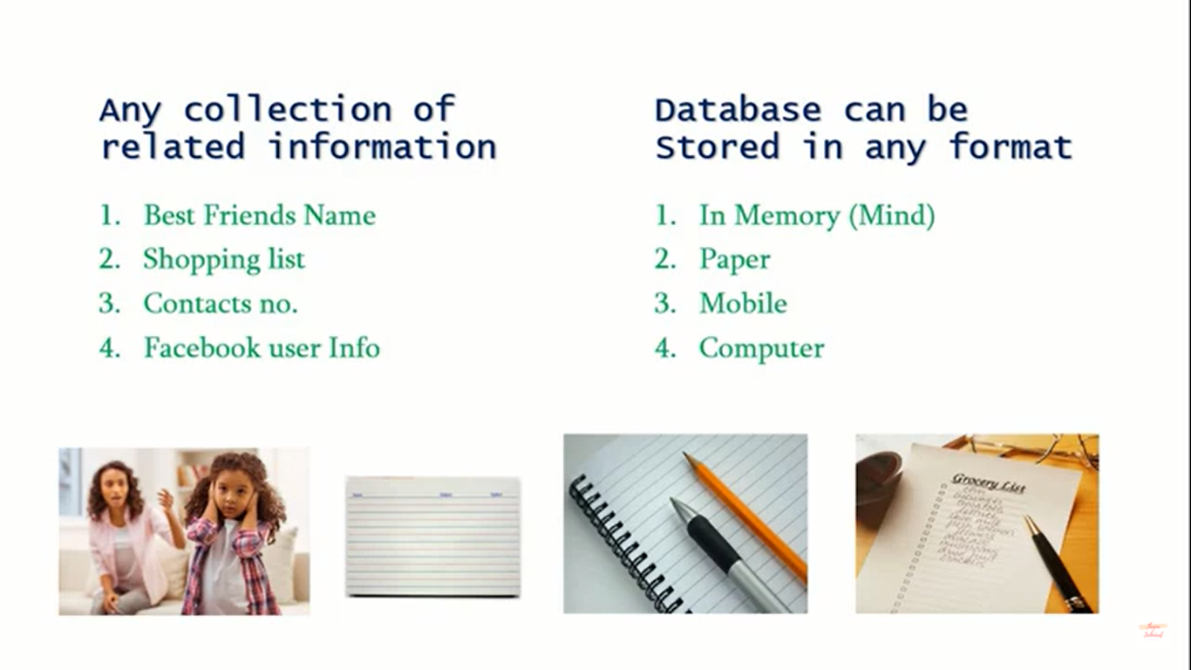

**Database Management System (DBMS):-**

In order to create/Manage the Database we need a software Application that is **Database Management System**. Any DBMS isn’t the actual Database.

1. Makes it easy to handled large amount of data.
2. Import/Exports of data.
3. Security, Backups etc..

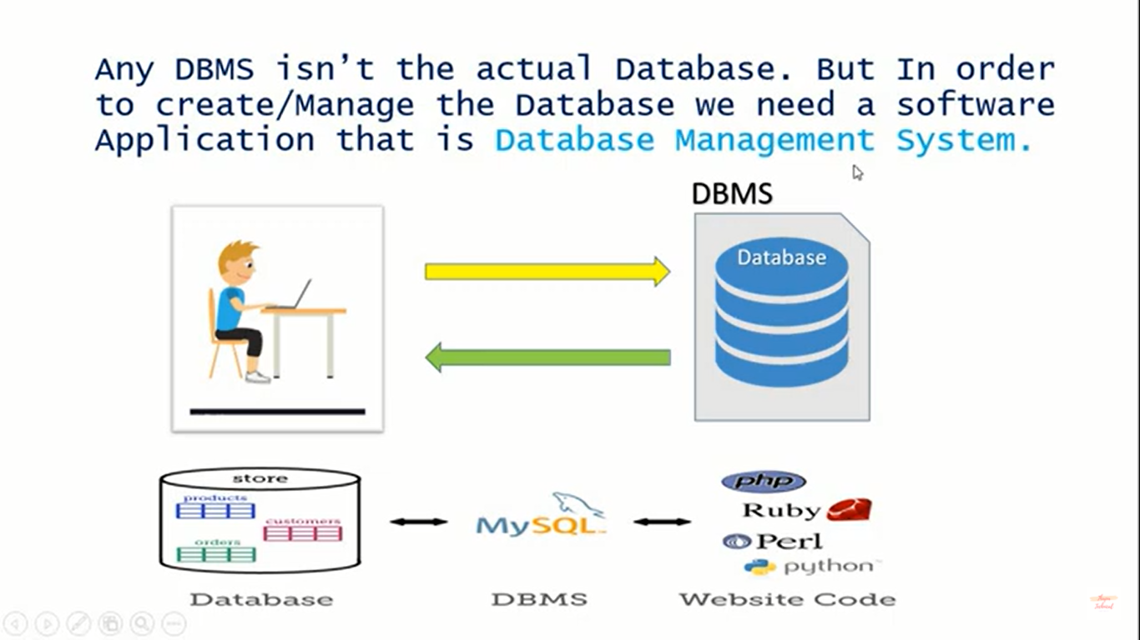

Bascially, there are various types of Database Management System (DBMS).  
But the following two DBMS are the most famous across the world are:

1. SQL
2. NoSQL

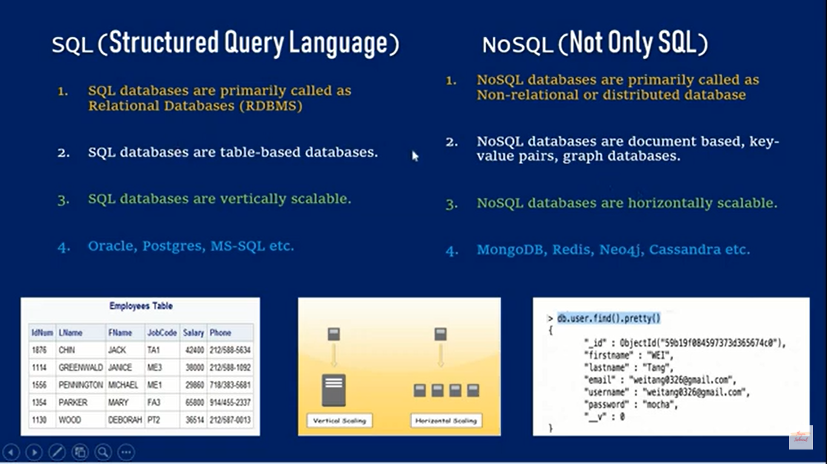

In this tutorial we are going to learn **SQL** (Structured Query Language) which is used for accessing, updating and maintaining data in a database of MySQL server or just say MySQL.

**MySQL** server is a **Relational** **Database Management System(RDBMS)** which is an open source database product, that allows users to keep the data that exists in a database organized.

We can use the **mysql client** to send commands to any mysql server; on a remote computer or your own. The mysql server is used to persist (maintain) the data and provide a query interface for SQL.   
The mySql clients purpose is to allow us to use that query interface.

**Note:**

* Data stores in the database of NoSQL DBMS in **JSON Format**.
* Most commonly used RDBMS is SQL where as most commonly used Non-relation database are MongoDB.

Thapa Technical Part-3 Video (

[MySQL Tutorial in Hindi #3: Introduction to MySQL in Hindi](https://www.youtube.com/watch?v=AFfFka0aHfA)

)